# CS 255 System Design Document Template

## UML Diagrams

### UML Use Case Diagram

### 

### 

### UML Activity Diagrams

### 

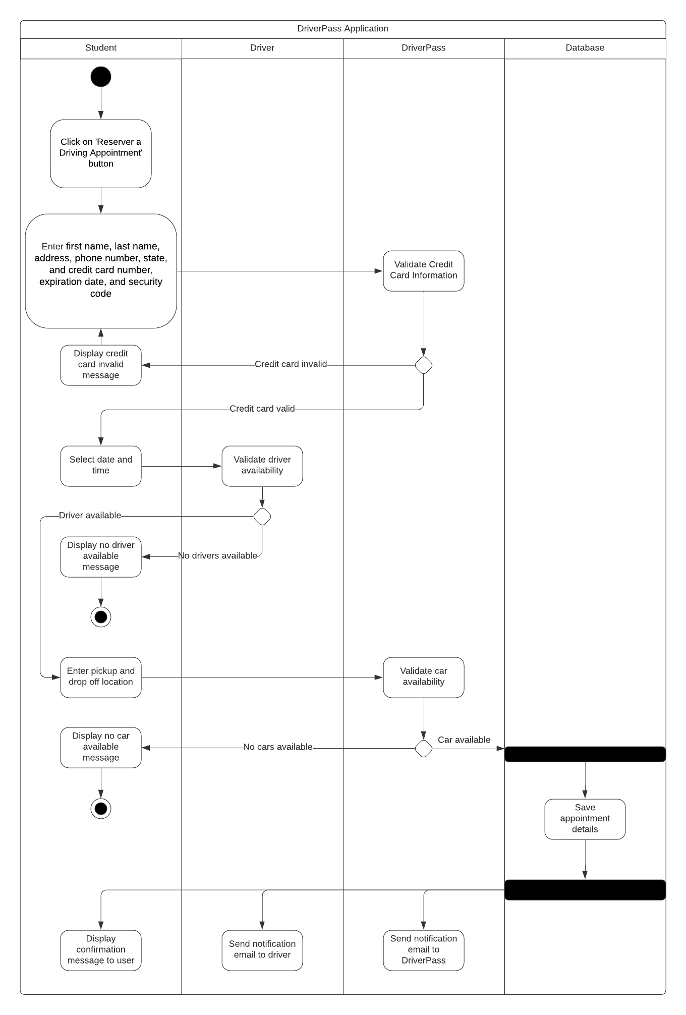

### UML Sequence Diagram

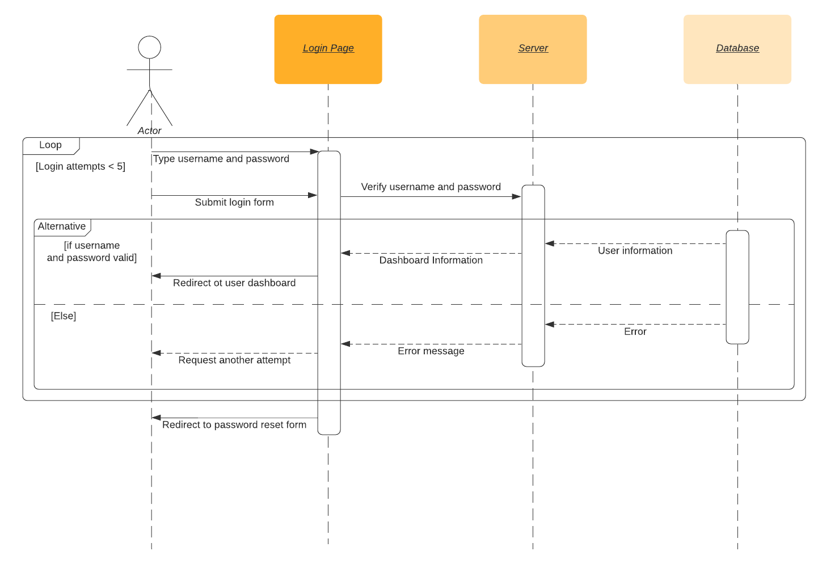

### UML Class Diagram

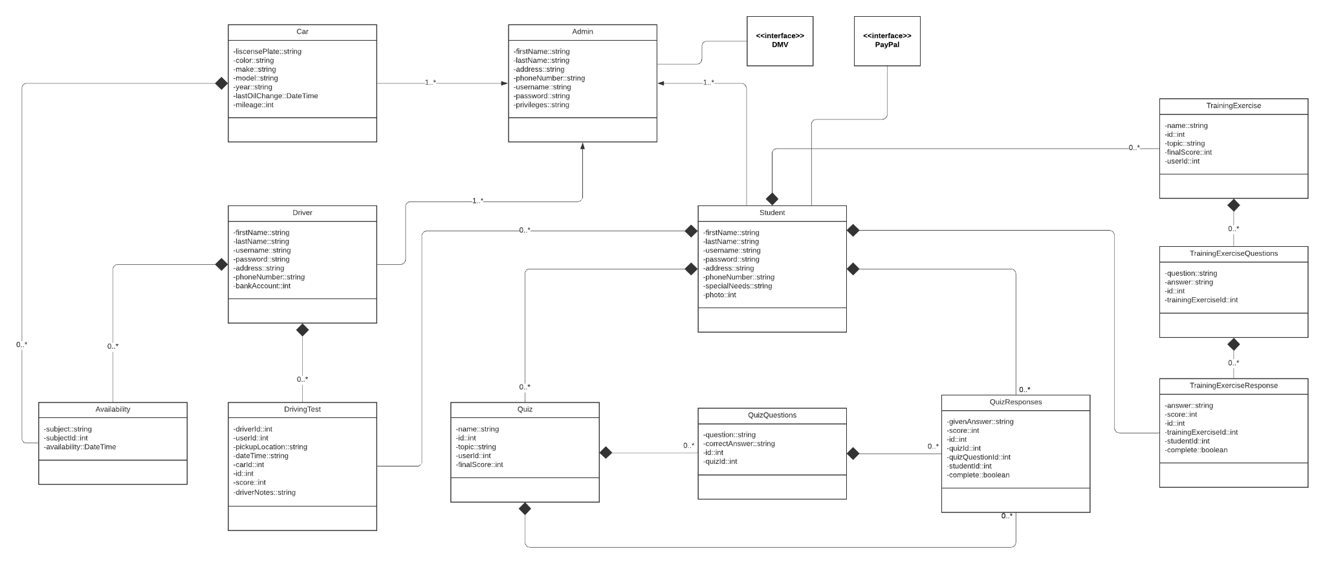

## Technical Requirements

* Hardware
  + Cars
  + Laptops for the Software Engineers
    - Laptops must contain enough CPU to run a large local environment
    - Laptops must contain enough RAM to store the database
  + Laptops for Admins
  + Phones for Admins and Drivers
* Software
  + The latest version of macOS
  + Mobile-responsive front-end framework software like React for development
    - Also must be able to run on all browsers and all major operating systems
  + Dynamic backend software that interacts well with our front-end software like Node.js for development
  + Norton security software installed on all development and admin devices
  + Scheduling software for drivers like Google Calendar
  + Software to send automatic emails
  + Software to pull DMV requirements
  + Cloud-based server
  + Cloud-hosted relational database
  + Encryption software to encrypt passwords in the database
  + Third-party credit card handling software like PayPal to handle payments
  + Software that enables Admis to download reporting CSVs
* Geographic information
  + The system must be available in multiple languages and multiple countries
  + The system must be able to be used 24 x 7 x 365
  + The system must only allow scheduling driving appointments in locations where drivers are available (20-mile radius)